Dicom viewer

1. Backgound Knowledge

* Dicom = 국제 표준 의료 영상 ( the international standard medical imaging information)
* Dicom viewer = software which will interpret the dicom information and display it as an image.
* 사용 언어 = C#

1. start UI

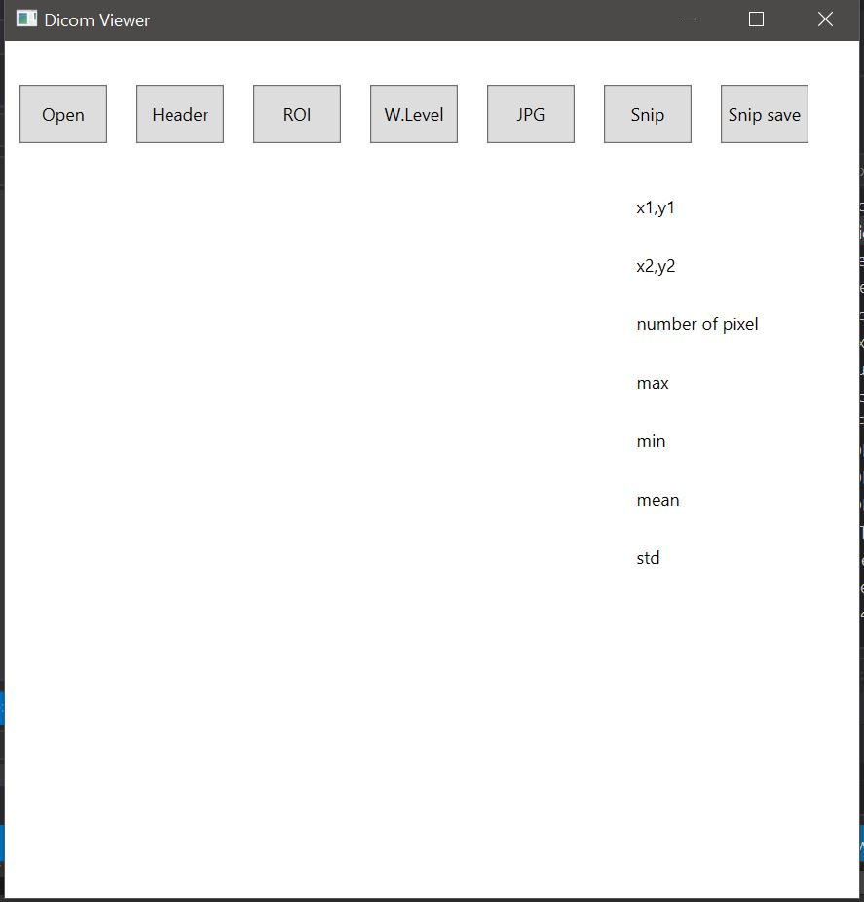

1. Button explaination

* open : display dicom medical image
* header : display dicom header
* ROI : drawing ellipse on the dicom image and measure every pixel in the ellipse
* W.Level : adjust contrast and brightness dicom image
* JPG : save dicom image into JPG file
* Snip : make snip image
* Snip save : save snip image into JPG file

1. display dicom image

* click “ open button “ -> click “ ser010img00001 “

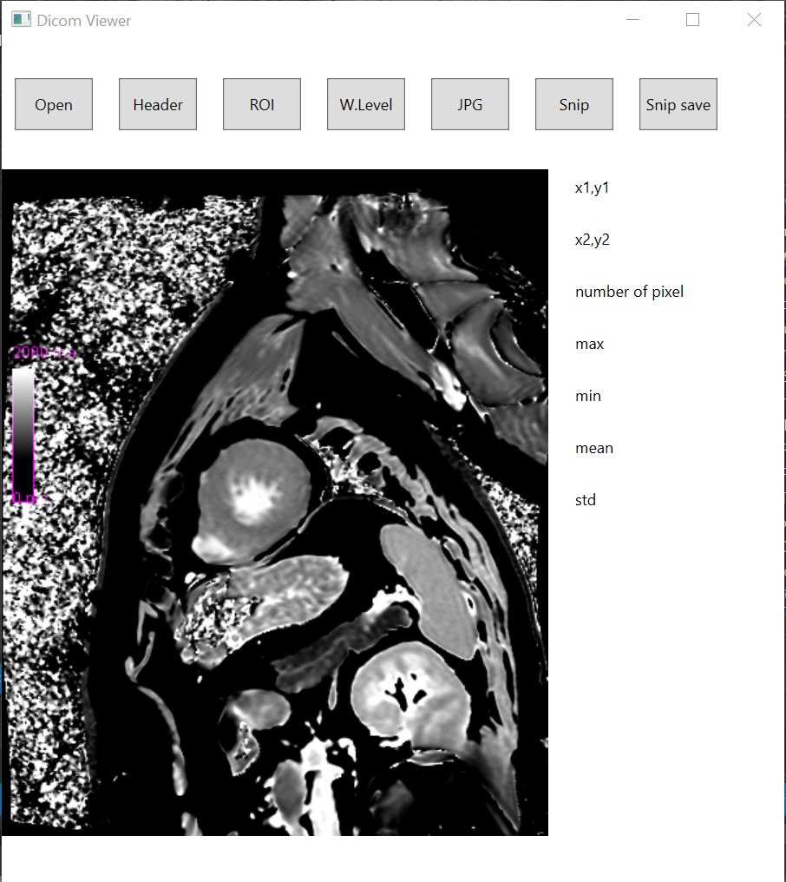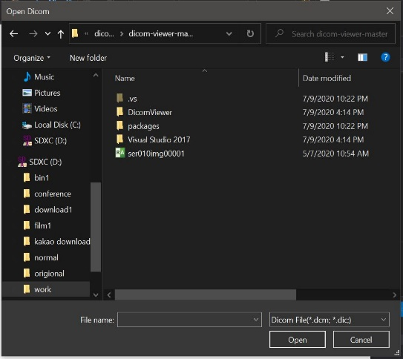

1. measure dicom

* measure every pixel in the ROI ellipse
* click “ ROI button “ -> mouse left click down on the image -> drag to right bottom side -> mouse left click up

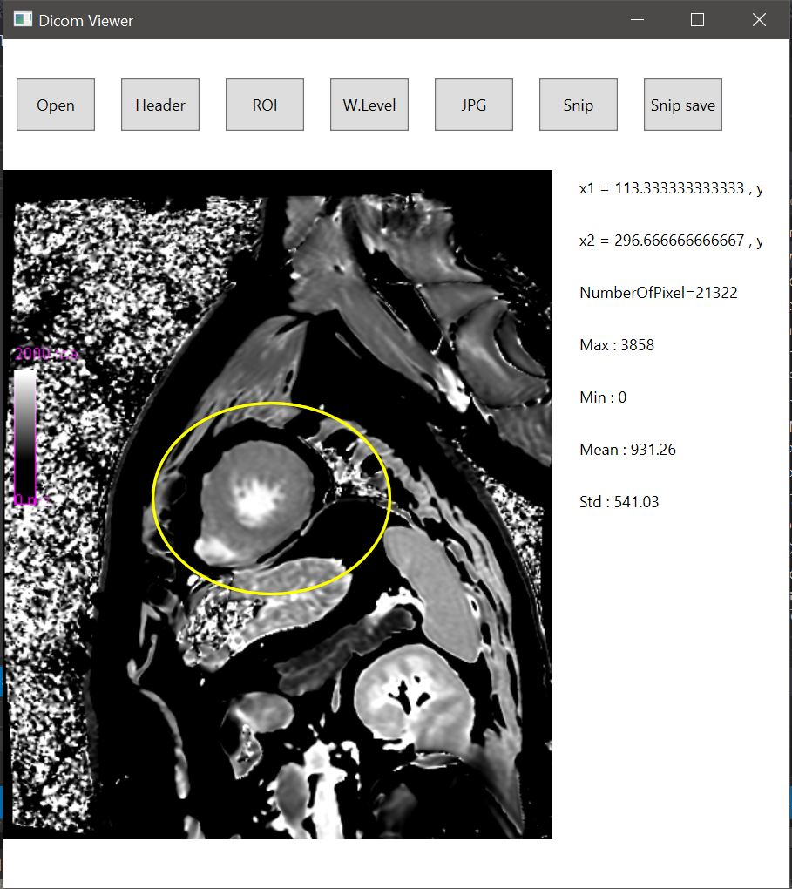

* x1,y1 = first mouse click coordinate(첫번째 마우스 클릭 좌표)
* x2,y2 = second mouse click coordinate (두번쨰 마우스 클릭 좌표)
* Number of Pixel = number of pixel in the ellipse
* Max = the maximum pixel value in the ellipse
* Min = the minimum pixel value in the ellipse
* Mean = the mean value of every pixel in the ellipse (평균)
* Std = the standard deviation of every pixel in the ellipse (표준편차)
* make ROI measurement excel file in the D drive

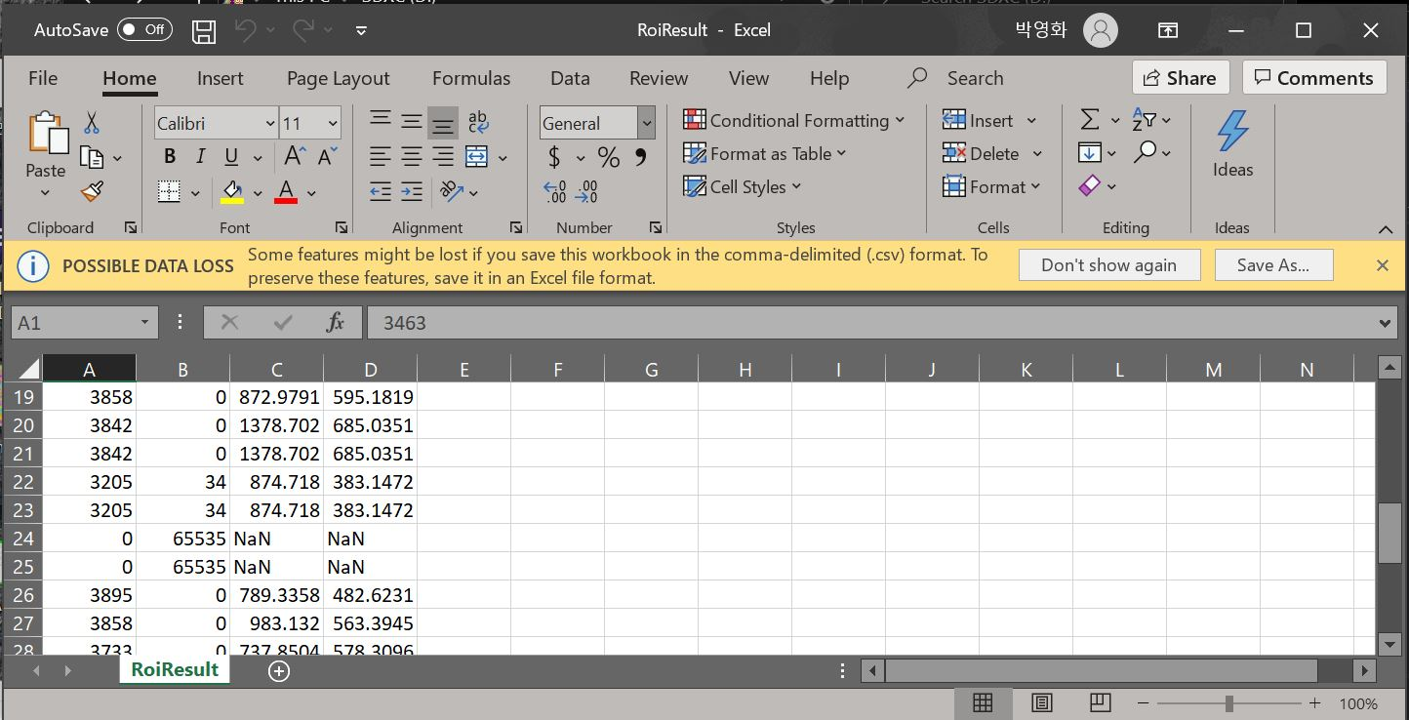

1. display dicom header

* dicom header = the information of dicom
* click “ header button “ -> file -> load -> click “ 8786098_POST ”

